**Conservation of Momentum**

**Equipment**

|  |  |  |
| --- | --- | --- |
| Quantity | Name | Model |
| 1 | 1.2 m PAScar Dynamics System | ME-6955 |
| 2 | Dynamics Track Mount | CI-6692 |
| 2 | RMS/IDS Adapters | ME-6569 |
| 2 | Rotary Motion Sensors | PS-2120 |
| 1 | Mass Balance | SE-8723 |
| 1 | 550 Universal Interface | UI-5001 |
| 1 | PASCO Capstone Software | UI-5400 |

**Introduction**

Elastic and inelastic collisions are performed with two dynamics carts of different masses. Magnetic bumpers are used in the elastic collision and Velcro® bumpers are used in the completely inelastic collision. In both cases, momentum is conserved.

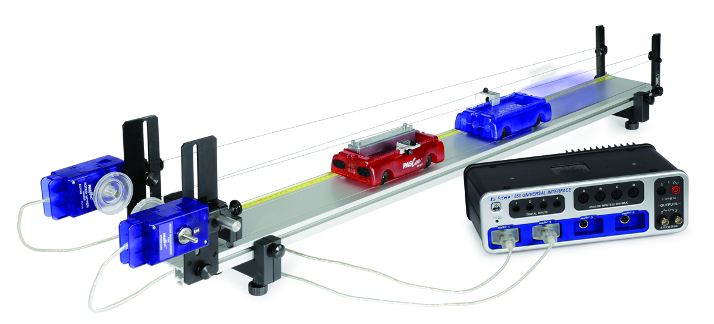Figure 1: Setup

Cart velocities are recorded using two Rotary Motion Sensors connected to the carts by string wrapped around pulleys. This measurement method adds very little friction to the experiment and, since the velocities are continuously monitored, any deceleration due to friction can be measured. The total kinetic energy before and after the collision is also studied.

**Theory**

The momentum of a cart depends on its mass and velocity.

(1)

The direction of the momentum is the same as the direction of the velocity. Duringa collision, the total momentum of the system of both carts is conserved because the net force on the two-cart system is zero. This means that the total momentum just before the collision is equal to the total momentum just after the collision. If the momentum of one cart decreases, the momentum of the other cart increases by the same amount. This is true regardless of the type of collision, and even in cases where kinetic energy is not conserved. The law of conservation of momentum is stated as

(2)

The kinetic energy of a cart also depends on its mass and speed but kinetic energy is a scalar.

(3)

The total kinetic energy of the system of two carts is found by adding the kinetic energies of the individual carts.

**Setup**

1. Level the track using the leveling screws on the track feet. When you place a cart at rest on the track, give it a little push in each direction. It should not accelerate in either direction.
2. Use the balance to find the mass of each cart. Include the string bracket on each cart.
3. 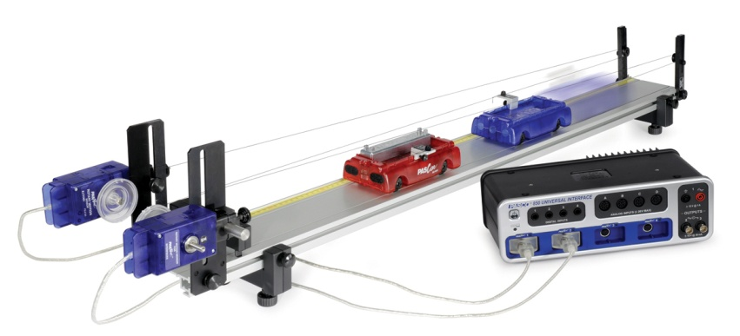Use one red and one blue cart so it is easy to distinguish between the carts. Attach a line of thread to each cart using the string bracket (see Figure 3). Run the thread over the largest pulley on the Rotary Motion Sensor (Figure 4a) and then over the small pulley on the other end of the track (Figure 4b), then return to the string bracket on the cart. The thread should not be too tight; just tight enough so the Rotary Motion Sensor pulley will turn when the cart moves.

*Figure 2: Complete Setup*

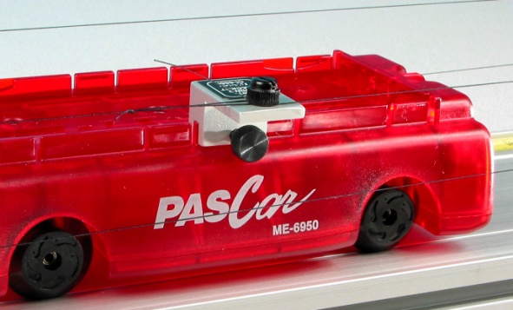

*Figure 3: Connecting thread to the cart*

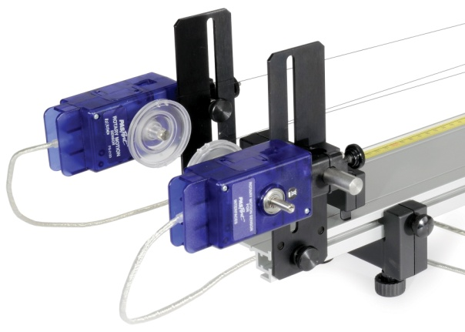 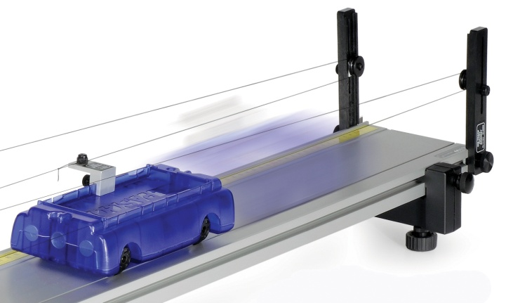

*Figure 4a: Threading the pulleys* *Figure 4b: Threading the pulleys*

1. Plug the Rotary Motion Sensor attached to the red cart into Channels P1 on the 550 interface and plug the Rotary Motion Sensor attached to the blue cart into Channels P2 on the interface.
2. Create a graph of velocity vs. time, putting both the Red Cart Velocity and the Blue Cart Velocity on the same vertical axis.
3. Checking the signs of the velocities: The goal is to have the velocities of both carts be positive to the right.
   1. Start recording and push the red cart to the right, toward the blue cart.
   2. If the velocity of the red cart is negative, click the “change sign” in the sensor menu.
   3. Push the blue cart to the right, away from the red cart.
   4. If the velocity of the blue cart is negative, click the “change sign” in the sensor menu.

**Procedure**

**I. Explosions**

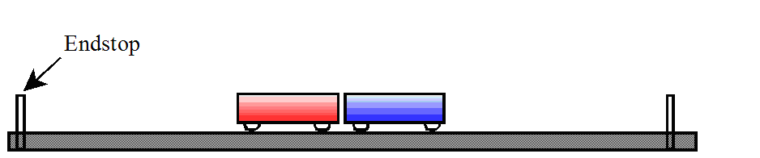**A. Equal Mass Carts**

1. Depress the plunger on one cart to position #2. Does it matter which cart has its plunger depressed? Place the two carts in contact with other in the center of the track.
2. Start recording and tap the trigger release to launch the carts. Hitting the trigger with a mass bar works well.
3. Stop recording before either cart reaches the end of the track.
4. On the velocity vs. time graph, find the velocity of the red cart just after the explosion. It may be helpful to expand the graph, to see just that area you are interested in.
5. Repeat step 4 to find the velocity of the blue cart after the collision.

**B. Unequal Mass Carts**



Use the balance to find the mass of two mass bars, and then place them both in the blue cart. Repeat steps 1 through 5 of part A.

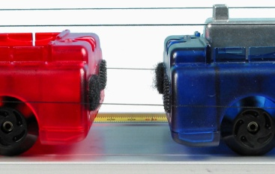

**II. Completely Inelastic Collisions**

Velcro® Bumpers for Inelastic Collisions

**A. Equal Mass Carts**

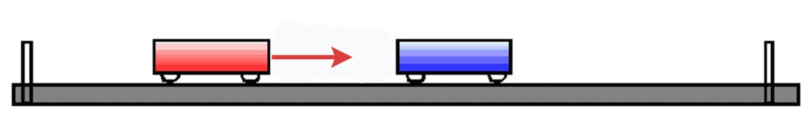

1. Place the red and blue carts at rest on the track as shown above, with the Velcro® bumpers facing each other.
2. Start recording and give the red cart a push toward the blue cart.
3. Stop recording before either cart reaches the end of the track.
4. On the velocity vs. time graph, find the velocity of the red cart just before and just after the collision. It may be helpful to expand the graph, to see just that area you are interested in.
5. The initial velocity of the blue cart is zero and its final velocity is the same as the red cart because they stick together.

**B. Unequal Mass Carts**

moving red-blue with mass cars.tif

1. Place the two mass bars in the blue cart.
2. Repeat the procedure from Part A.

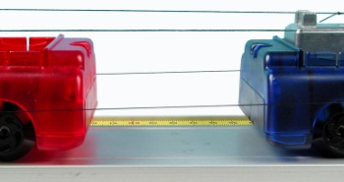**III. Elastic Collisions**

Magnetic Bumpers for Elastic Collisions

**A. Equal Mass Carts**

1. Place the red and blue carts at rest on the track, with the magnetic bumpers facing each other.
2. Start recording and give the red cart a push toward the blue cart.
3. Stop recording before either cart reaches the end of the track.
4. On the velocity vs. time graph, find the velocity of the red cart just before and just after the collision. It may be helpful to expand the graph, to see just that area you are interested in.
5. The initial velocity of the blue cart is zero. Find the final velocity blue cart.

**B. Unequal Mass Carts**

1. Place the two mass bars in the blue cart.
2. Repeat the procedure from Part A.

**Analysis**

1. Calculate the initial and the final momentum for each cart for each of the collisions.
2. Calculate the percent difference between the total initial momentum and the total final momentum for each collision.



1. Calculate the initial and the final kinetic energy for each cart for each of the collisions.
2. Calculate the percent of the total kinetic energy lost for each collision.

**IV. Total Momentum and Total Energy**

1. Create these calculations in PASCO Capstone:

p_total=m₁ v₁+m₂ v₂

KEtotal=KE₁+KE₂

KE₁=1/2*m₁ v₁²

KE₂=1/2*m₂ v₂²

v₁=[Red Velocity, Ch P1(m/s), ▼]

v₂=[Blue Velocity, Ch P2(m/s), ▼]

m1= mass of Red cart

m2= mass of Blue cart

1. Graph ptotal vs. time and add a second plot area for KEtotal vs. time.
2. Examine the graphs to see what happens before, during, and after the collisions. Look at each type of collision and record your observations.

**V. Conclusion**

In general, what did you learn about conservation of momentum and kinetic energy in different types of collisions?

1. Was momentum conserved for all types of collisions?
2. Was total velocity conserved for all types collisions?
3. Was energy conserved for all types of collisions? What happens to the initial kinetic energy that is lost in a collision?